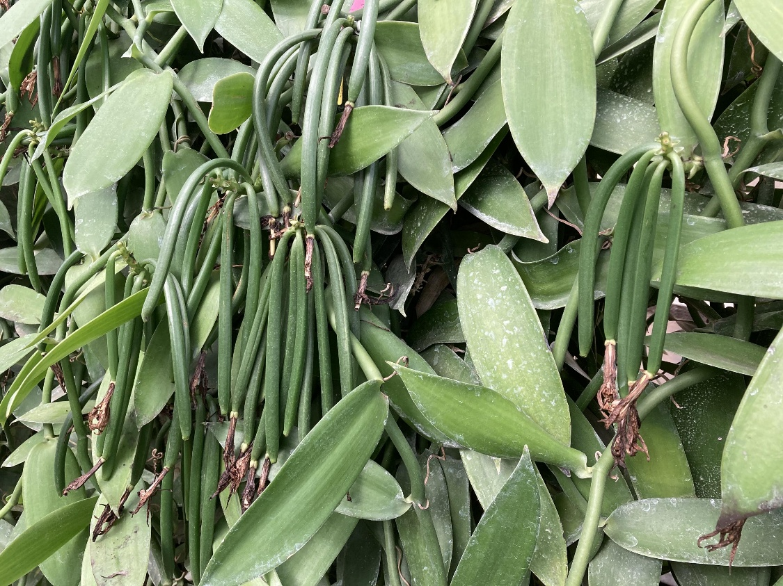
Fig. 1. It takes four years to cultivate and mass-produce vanilla pods.
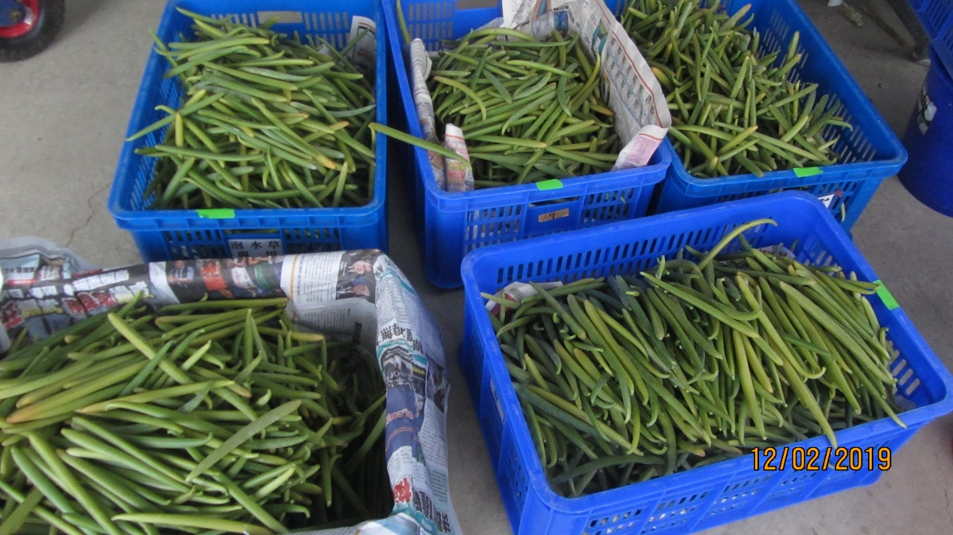
Fig. 2. Fresh vanilla pods do not have a vanilla scent when they are harvested.
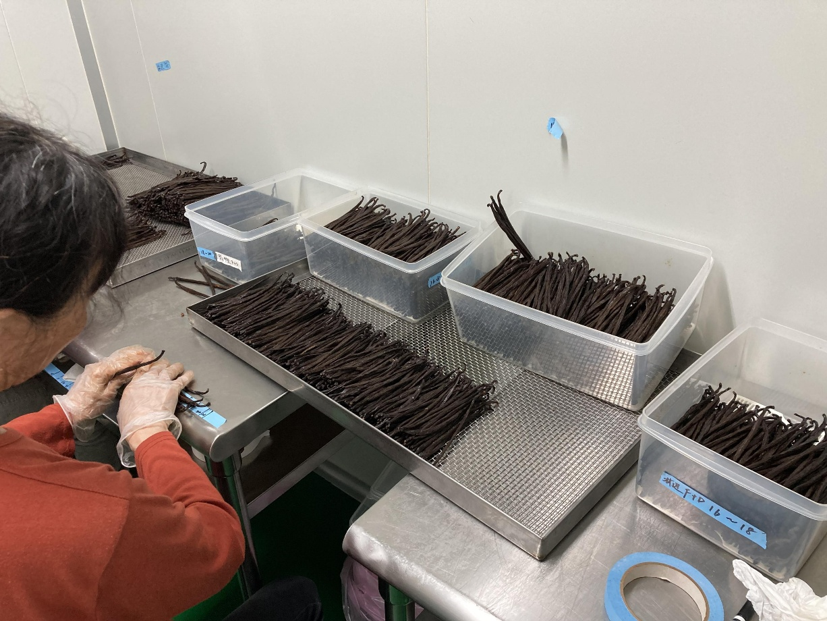
Fig. 3. Processed vanilla pods are selected and sorted after processing.
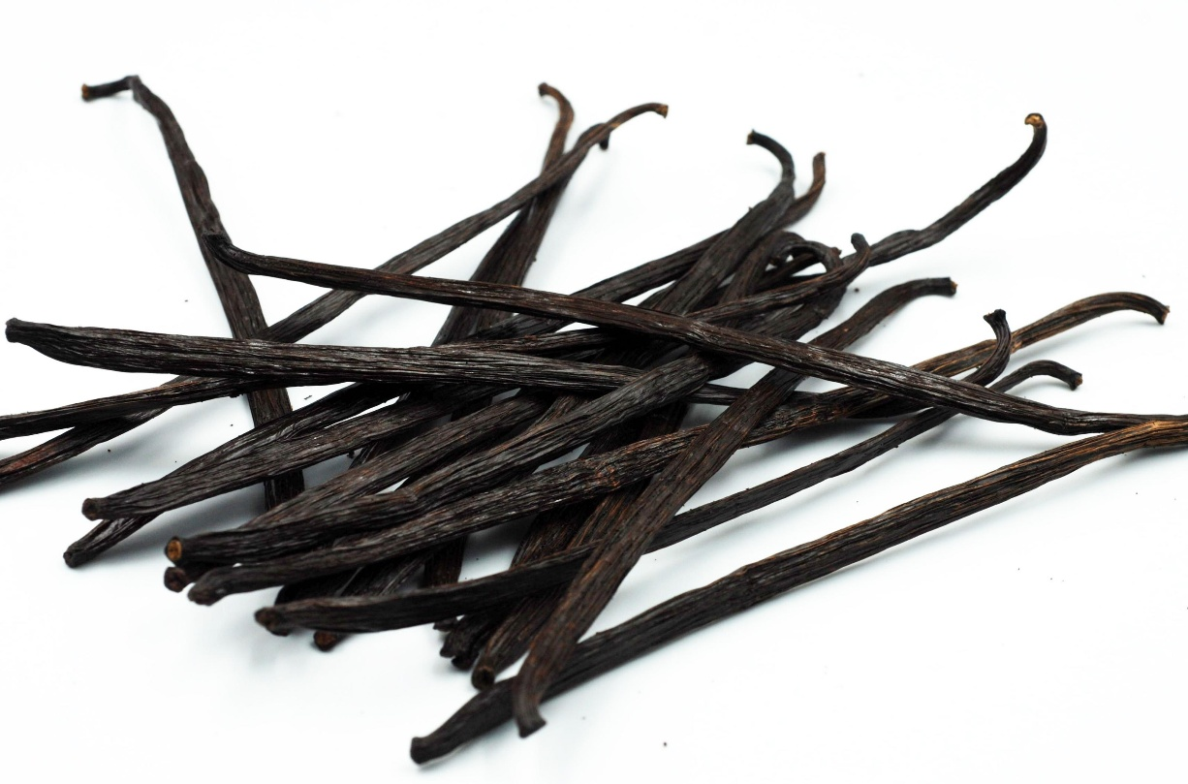
Fig. 4. Processed Vanilla Pods.
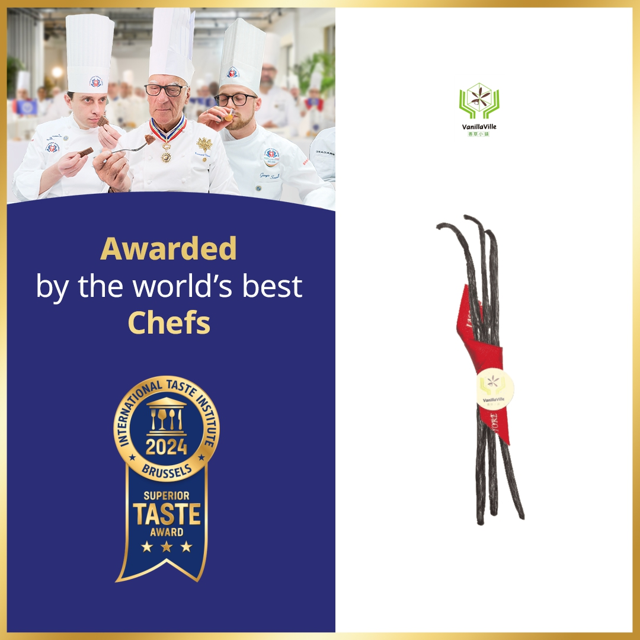
Fig. 5. The vanilla pods produced by Chen Jin-chao(陳錦超) in Linbian Township, Pingtung County,
have been awarded the three-star Superior Taste Award by the International Taste Institute.
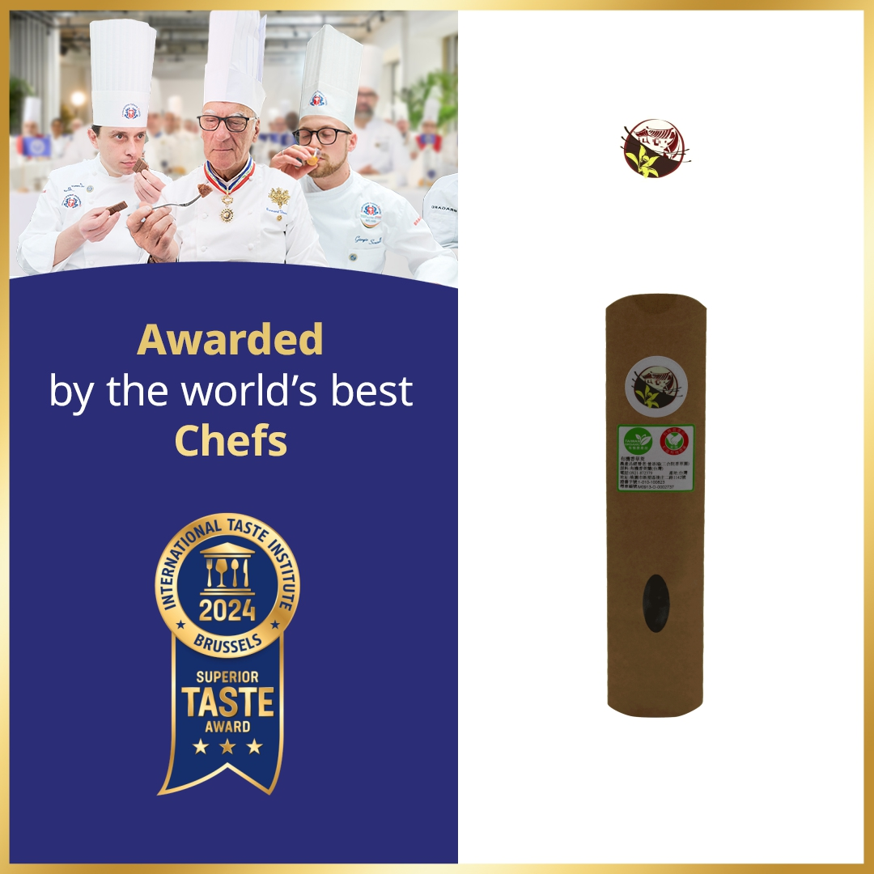
Fig. 6. The vanilla pods from the Sanheyuan Vanilla Garden(三合院香草園) in Taoyuan City
have been awarded the three-star Superior Taste Award by the International Taste Institute.
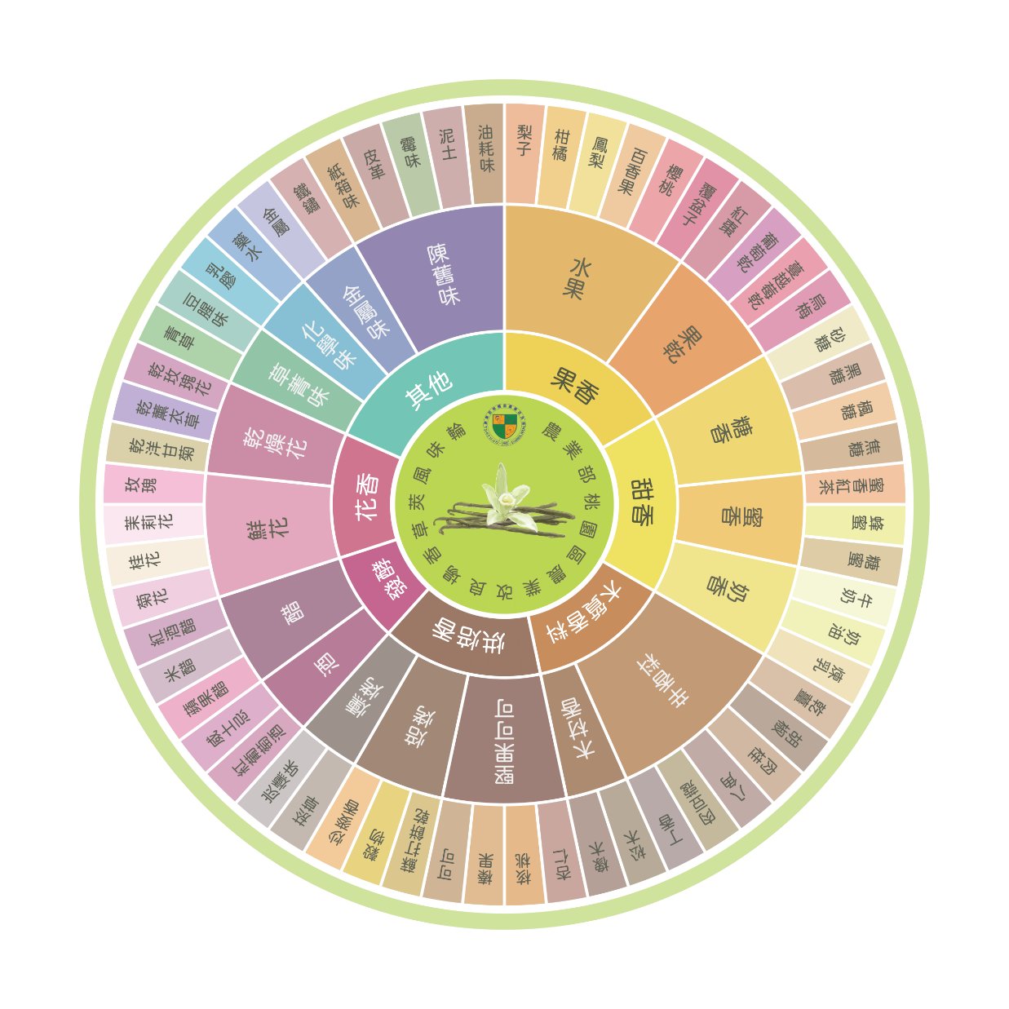
Fig. 7. Taiwanese Vanilla Pod Flavor Wheel.

