Propolis as feed additive used in the geese ration
賈玉祥 粘碧珠 游宗憲
Summary
Most of propolis were pharmacological and biological activity. The aim of the experiment was to study the effect of propolis which was added to the balanced ration on intestinal development and growth performance of the geese. The experiment were divided into four treatment groups：the control group which were no propolis added；200ppm group（G200）which were added 200ppm propolis；400ppm group（G400）which were added 400ppm propolis；800ppm group（G800）which were added 800ppm propolis.. The market weight of four groups at twelve week age were 4.80, 4.74, 4.78 and 4.87kg, respectively. There were no significant among groups (p>0.05). The measurement of intestinal morphology at 12 week age of geese included villus height, villus width, villus circumference, villus area and crypt depth of duodenum, jejunum and ileum. The results were shown that in the duodenum the circumference and area of the villus of G800 was the highest among groups. (P <0.05), the villlus height of G400 was the highest among groups (p <0.05), in the jejunum the villus area of G800 and crypt depth of G400 were significant among groups (p<0.05); and in the ileum the villus height and crypt depth of G400 were significant among groups (p<0.05). The propolis added to the balance rations could be got the better growth of intestinal development in geese. But there were no improvement on the growth performance of the geese.

Key words: Propolis, ration, geese

Introduction
Propolis contained over two hundred kinds of substances. The essence of propolis was the flavonoids which were about 30-40%, the highest content of propolis (Marcucci, 1995; Bankova et al., 2000 ). Most of propolis were pharmacological and biological activity. The main components of such substances were capable of regulating body metabolism, antioxidant, anti-inflammatory, anti-allergy, anti-cancer and immunity(Chen et al., 2004). The biological activity of propolis products were closely related to its chemical composition, and the chemical compositions of propolis were also related to original place, season, species and other factors (Bankova et al., 1998, Chen et al., 2008). Comparing antimicrobial resistance and geographical origin of different chemical composition of propolis the results were shown that all samples have significant antibacterial and antifungal（Kujumgiev et al.,1999）. The objective of this study was to evaluate propolis as a feed additive added to the geese balance ration.

Materials and Methods
Geese and Feeding

The care and use of all geese were according to the Regulations of Laboratory Animals, Changhua Animal Propagation Station, Livestock Research Institute (CAPS-LRI, locating at 23◦51'N and 120◦33'E), Council of Agriculture, Taiwan.. The goslings immediately after being hatched were gender determined and foot banded. Lighting and heat were supplied 24 h a day with an incandescent 60-Watt bulb hanging at a height for maintaining ambient temperature about 28◦ C during 0 to 2 week age, and without artificial heat source thereafter. The goslings were moved from nursery house to growing house with water pool at 2 week age. The geese were fed ad libitum with commercial rations of 20% CP plus 2,900 Kcal ME/kg and 15.0% CP plus 2,750 Kcal ME/kg during 0 to 4 and 5 to 12 week age, respectively.

Experimental design

A randomized complete design included three treatments at Changhua Animal Propagation Station (23°51'N, 120°33'E), COA-LRI, Taiwan. The experiment comprised one hundred and sixty White Roman geese. The experiment were divided into four treatment groups, the control group which was no propolis to the balanced ration, 200ppm group（G200）which was added 200ppm propolis to the balanced ration, 400ppm group（G400）which was added 400ppm propolis to the balanced ration; 800ppm group（G800） which was added 800ppm propolis to the balanced ration. Each group comprised ten goslings which had half male and half female. There were four replicated. The experiment period was 12 weeks (0-12 week age). During the experiment period geese were weighed at 1 day old, 4 week age, 8 week age and 12 week age, respectively.

Sampling

Two geese were randomly picked one male and one female from each group. There were sacrificed at 12 week age. Five centimeter of intestinal parts which included duodenum, jejunum and ileum were taken from sacrificed geese. Each intestinal parts was immediately immersed 10% formalin solution and was prepared for intestinal section. Using the electron microscope with OLYSIA Bio Report the height, width, circumference, area, and crypt depth of duodenum, jejunum and ileum were measured.

Statistical Analysis

The data were analyzed by one way ANOVA. When significant(P <0.05) effects were found. with Statistical Analysis System (SAS, 2004) for statistical analysis. The general linear model procedures were used. Data are presented as means. ±SE.

Results and Discussion
Growth performance
The growth performance of different propolis concentrations which were added to the geese balance ration were shown on table 1. In the whole feeding period the feed conversion of control group, G200, G400 and G800 were 5.17, 4.91,5.08 and 5.13 respectively. The feed conversion of G200 was better than those of other groups. There were no significant difference among groups(P>0.05). The daily gain of four groups were the same （0.06kg/day）. The final weight at twelve week age of control group, G200, G400 and G800 were 4.80kg, 4.74kg, 4.78kg and 4.87kg, respectively. There were also no significant difference among groups(P>0.05). The nursery rate of control group,G200, G400 and G800 were 97.5%, 95%, 95%and 97.5%, respectively. There were no improvement on growth performance when propolis were added to the balance ration.

Table 1. The growth performance of different propolis concentrations added to the geese ration at twelve week age

Item | group
Item | control | G200 | G400 | G800
Initial weight (kg) | 0.11 | 0.11 | 0.11 | 0.11
Final weight (kg) | 4.80 | 4.74 | 4.78 | 4.87
nusery rate (%) | 97.5 | 95 | 95 | 97.5
Feed intake (kg)/bird | 24.25 | 22.75 | 23.72 | 24.42
Daily gain (kg) | 0.06 | 0.06 | 0.06 | 0.06
Feed conversion (F/G) | 5.17 | 4.91 | 5.08 | 5.13
.
Intestine characteristics
At the 12 week age intestine characteristics were shown on table 2. The measurement of intestinal morphology at 12 week age of geese included villus height, villus width, villus circumference, villus area and crypt depth of duodenum, jejunum and ileum. The results were shown that in the duodenum the circumference and area of the villus of G800 was the highest among groups. (P <0.05), the villlus height of G400 was the highest among groups (p <0.05), in the jejunum the villus area of G800 and crypt depth of G400 were significant among groups (p<0.05); and in the ileum the villus height and crypt depth of G400 were significant among groups (p<0.05). In the duodenum, in the jejunum and in the ileum the villus height, width, circumference and area of G800 was better than those of the control group. .The results indicated that the amount of propolis added to 800 ppm of the balance ration could improve the small intestinal growth of the geese（Fig1.） .

Table2 The small intestine characteristics of different propolis concentrations added to the geese ration .at twelve week age

Group |  | Height  (μm) | Width  (μm) | Circumference  (μm) | Area  (μm²) | Crypt depth  (μm)
control | duodenum | 1211.17  ±127.23 | 154.25  ±37.29 | 1656.22  ±357.27 | 131010.30^{b}  ±22549.60 | 431.27  ±94.12
G200 | duodenum | 1135.48^{b}  ±174.26 | 134.30  ±32.11 | 1516.49^{b}  ±318.32 | 95720.84^{d}  ±24157.94 | 430.22  ±57.63
G400 | duodenum | 1400.75ª  ±250.97 | 150.43  ±23.30 | 1549.82  ±310.21 | 114055.11^{c}  ±12113.69 | 411.96  ±56.81
G800 | duodenum | 1345.78  ±193.39 | 157.75  ±31.57 | 2051.88ª  ±346.94 | 165187.87ª  ±25625.23 | 410.38  ±47.98
control | jejunum | 1354.15  ±229.25 | 113.63  ±20.44 | 1973.52  ±536.59 | 102070.72^{b}  ±40014.58 | 415.17^{ab}  ±114.89
G200 | jejunum | 1231.18  ±256.56 | 125.04  ±18.89 | 2004.32  ±185.60 | 124018.93^{ab}  ±16600.85 | 368.07^{b}  ±74.58
G400 | jejunum | 1607.14  ±631.93 | 132.26  ±30.93 | 1696.81  ±636.54 | 95947.71^{b}  ±37216.04 | 492.73ª  ±150.74
G800 | jejunum | 1373.77  ±274.38 | 133.22  ±24.53 | 2128.73  ±518.35 | 138927.54ª  ±30539.35 | 359.20^{b}  ±75.55
control | ileum | 1306.67^{b}  ±123.49 | 113.66  ±27.28 | 2028.08^{ab}  ±151.83 | 111619.82  ±20531.91 | 358.72^{ab}  ±157.07
G200 | ileum | 1306.90^{b}  ±159.18 | 116.05  ±16.76 | 2074.70ª  ±280.40 | 112705.26  ±13323.25 | 321.20^{ab}  ±68.13
G400 | ileum | 1593.38ª  ±439.54 | 130.35  ±30.93 | 1706.14^{b}  ±406.14 | 117065.59  ±35223.27 | 429.27ª  ±84.90
G800 | ileum | 1412.53^{ab}  ±154.27 | 116.53  ±27.07 | 2312.94ª  ±305.30 | 125729.83  ±21275.94 | 286.72^{b}  ±56.59
Mean ± SE (standard error ).
abc Means in the same column with the different superscript differ significantly (P<0.05).

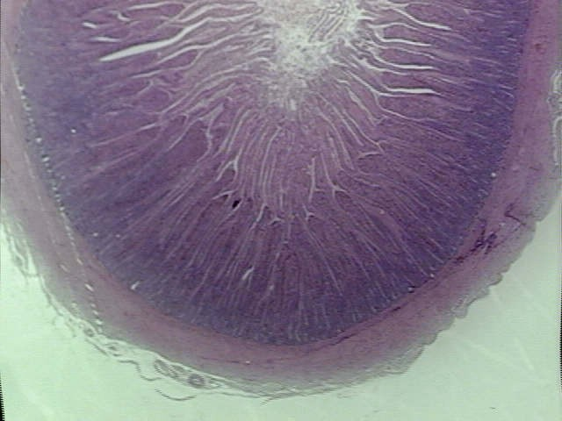 | 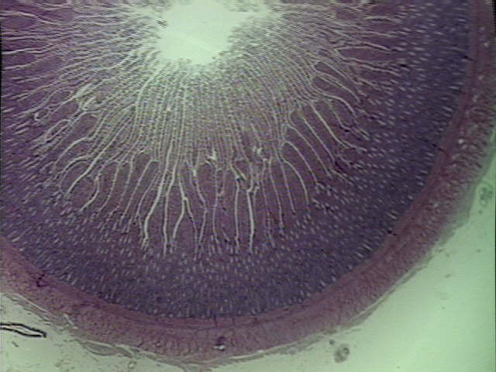 | 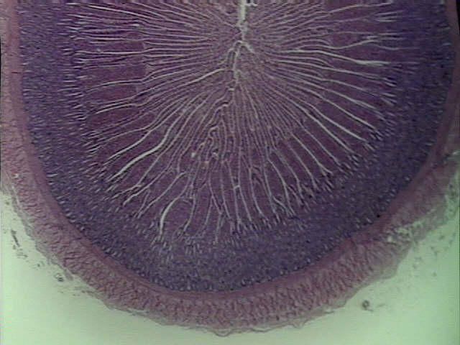
duodenal villus | jejunum villus | ileum villus
Fig. 1. The geese intestinal biopsy of the 12 weeks old.

Conclusion
It need further investigation when the propolis were used as feed additive. The heat stability of propolis was high. The components of propolis were not any change when feed processing was necessary... The quality of propolis would be influenced by orignal place, season, collect method, collect time, processing method, and product type（Bankova et al., 1998, Chen et al., 2008）. In general propolis price was high when it was compared with other feed additives. For the market competition it need find new by-products of propolis which had the same function components and low price advantage.

Acknowledgments
The author would like to thank the colleagues of Changhua Animal Propagation Station to provide their specialized helps and animal care.

References
Bankova, V., Boudourova-Krastevaa, G., Popova, S., Sforcinb, J. M. and Funarib, S. R. C. (1998) Seasonal variations of the chemical composition of Brazilian propolis. Apidologie 29: 361-367.
Bankova, V. S., de Castro, S. L. and Marcucci, M. C. (2000) Propolis: recent advances in chemistry and plant origin. Apidologie 31: 3-15.
Chen, C. A., Wu, C. L. and Lin, J. K. (2004) Propolin C from propolis induces apoptosis through activating caspases, bid and cytochrome C releasein human melanoma cells. Biochemical Pharmacology. 67:53-66.
Chen, Y. W., Wu, S. W., Ho, S. B., Lin, Huang, C. Y.., and Chen, C. N. (2008). Taiwamese propolis collected from different seasoms and locations J. Sci. Food Agric. 88:412-419.
Farnesi A.P., Aquino-Ferreira, R., De Jong, D., Bastos J. K.and A. E. E. Soares. (2009) Effects of stingless bee and honey bee propolis on four species of bacteria. Genetics and Molecular Research 8 (2): 635-640.
Kujumgiev A., Tsvetkova I., Serkedjieva Yu., Bankova V., Christov R., Popov S. (1999) Antibacterial, antifungal and antiviral activity of propolis from different geographic origins J Ethnopharmacol 64: 235-40.
Marcucci M. C. (1995) Propolis: chemical composition, biological properties and therapeutic activity. Apidologie 26: 83-99.
SAS Institute. (2004) SAS/STAT Guide for Personal Computers. Version 9.0.1.SAS Inst. Inc., Cary, NC.

