重要出口種子種傳病原檢測技術之建立
蘇士閔^{1,5}、邱燕欣¹、鍾文全²、王慧如³、劉俊延³、簡良芬³、魏苹珊⁴
¹行政院農業委員會種苗改良繁殖場助理研究員
²行政院農業委員會種苗改良繁殖場研究員
³行政院農業委員會種苗改良繁殖場研究助理
⁴行政院農業委員會種苗改良繁殖場前研究助理
⁵通訊作者
關鍵詞：種傳病原、檢測、出口種子
摘 要
本場為因應台灣蔬菜種子外銷需求，自2013年起接受防檢局委託，已建立14項種子病原檢測作業流程，可檢測對象包含十字花科黑腳病菌、瓜類蔓枯病菌、菜豆炭疽病菌、豌豆葉斑/果莢黑斑病菌、茄科細菌性斑點病菌、番茄細菌性葉斑病菌、菸草嵌紋病毒、豌豆種媒嵌紋病毒、南瓜嵌紋病毒、香瓜茄嵌紋病毒、香瓜壞疽斑點病毒、菸草微綠斑駁病毒、豌豆早褐病毒及六種番茄與茄科種子類病毒等22個病原。

前 言
近年來因全球種子貿易日趨頻繁，種傳病害也越來越受重視。除國家檢疫的病原生物外，因種傳病害造成作物損失的病原項目也備受關注，從ISTA在種子健康檢查之病原種類逐年增加亦可見其端倪。而在國際種子貿易中檢測方法的可信度與一致性是種子健康檢查結果是否受認可的最重要因素。目前除國際種子檢查協會(International Seed Testing Association, ISTA)與I際種子聯盟(International Seed federation, ISF)公告的檢測方法外，許多病原的檢測方法未被廣泛接受。以瓜類細菌性果斑病菌(Acidovorax avenae subsp. citrulli, Aac)為例， 目前全世界以美國Eurofins STA實驗室與荷蘭 Naktuinbouw實驗室的檢測結果較具公信力；我國屬於Aac之疫區，種子業者外銷瓜類種子時多送往前述二實驗室進行檢測，唯曠日廢時且所費不貲，因此種子業者積極要求政府相關單位建立檢測方法，提供種子業者檢測服務以強化種子外銷產業。

種傳病原檢測作業流程簡介
十字花科黑腳病菌(Phoma lingam)
主要係依據ISTA所公告之濾紙法進行種子上的P. lingam培養，觀察病原真菌的形態特徵進行鑑定。樣品量為種子1,000顆。檢測過程中使用2,4-D鈉鹽溶液可抑制種子發芽，減少發芽後的幼苗對觀察的干擾。判別結果時，檢查受感染種子及其周邊濾紙上是否有柄子器產生。有觀察到柄子器的種子記錄為受感染種子並計算帶菌率。
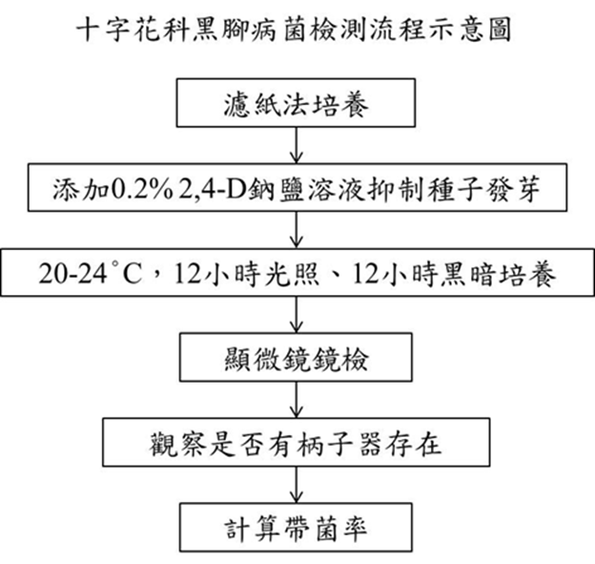
圖一、十字花科黑腳病菌檢測流程示意圖

瓜類蔓枯病菌(Didymella bryoniae)
利用冷凍濾紙法(Deep freezing blotter test, DFB)進行種子上的D. bryoniae培養，觀察目標病原真菌的形態特徵進行鑑定。樣品量為種子400顆。檢測過程中會將受測樣品移到-20 °C以抑制種子發芽。判別結果時以解剖顯微鏡放大50倍率，檢查受感染種子及其周邊濾紙上是否有柄子器產生。有觀察到柄子器的種子記錄為受感染種子並計算帶菌率。
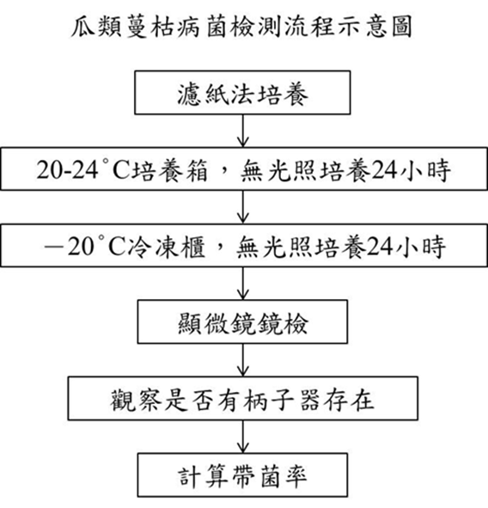
圖二、瓜類蔓枯病菌檢測流程示意圖

菜豆炭疽病菌(Colletotricum lindemuthianum)
診斷方法係利用紙巾測試法(Paper toweling test)進行種子上的C. lindemuthianum培養，觀察目標病原真菌的形態特徵進行鑑定。報驗樣品量為種子400顆。培養7天後，將單層紙巾移除，用肉眼觀察經去除種皮的子葉上有無明顯與健康組織區隔的黑色病斑，以25倍放大倍率觀察每個病斑上有無帶有暗褐色剛毛(setae)的分生胞子盤(acervuli) ，最後計算帶菌率。
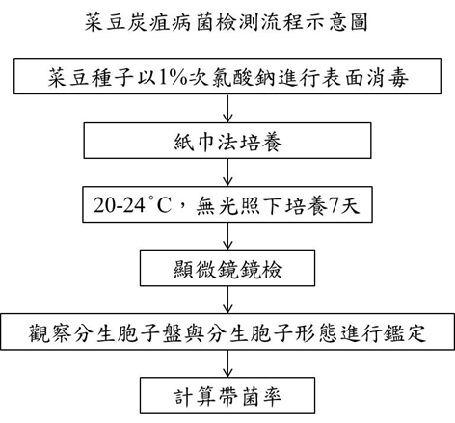
圖三、菜豆炭疽病菌檢測流程示意圖

豌豆葉斑病菌(Ascochyta pisi)
診斷方法係利用麥芽瓊酯培養基(malt agar，MA)或馬鈴薯葡萄糖瓊酯培養基(potato dextrose agar，PDA)進行種子上的目標病原真菌培養，觀察目標病原真菌的形態特徵進行鑑定。
樣品量為種子400顆。培養7天後，用肉眼觀察種子表面有無白色菌絲纏繞，疑似菌落以25倍放大倍率觀察菌落邊緣有無波浪狀菌絲。培養基背面可見菌落中央呈深橘褐色，至菌落外圍顏色漸淡。最後計算帶菌率。
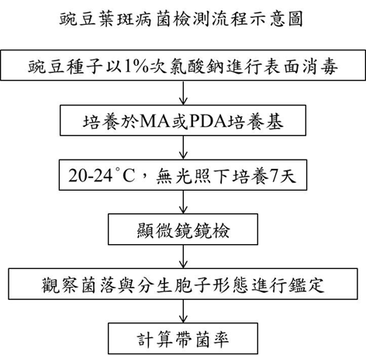
圖四、豌豆葉斑病菌檢測流程示意圖

茄科細菌性斑點病菌(Xanthomonas spp. on tomato and pepper)
能引起茄科細菌性斑點病之病原細菌包含有X. euvesicatoria、X. vesicatoria、X. perforans及X. gardneri等四種。檢測方法為萃取種子內部及外部附著之細菌，將種子萃取液以稀釋平板法培養在mTMB培養基(modified Tween medium B)與CKTM培養基兩種半選擇性培養基上，分離出具活性的Xanthomonas屬細菌，接著移植至YDC培養基上再確認菌落形態，最後利用病原性測試，將疑似菌落接種到感病番茄品種上，在2-4天內觀察是否有病徵表現以確認是否帶有病原細菌。本病原細菌檢測樣品量需要種子30,000顆。

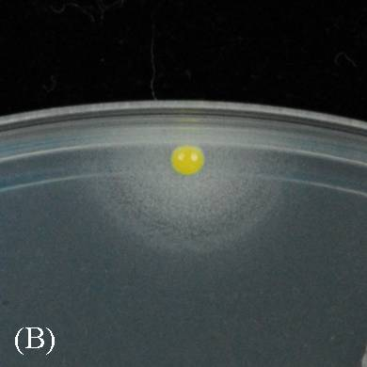
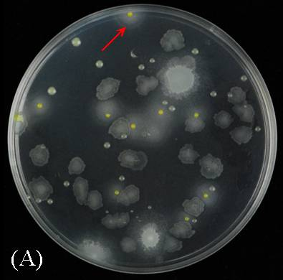
圖五、在mTMB培養基上淡黃色的Xanthomonas perforans菌落(A紅色箭頭所指)，其外圍產生白色乳化沉澱圈(B)。

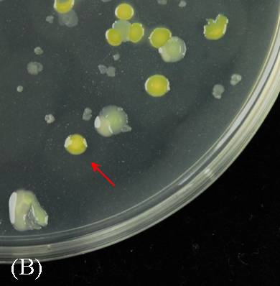
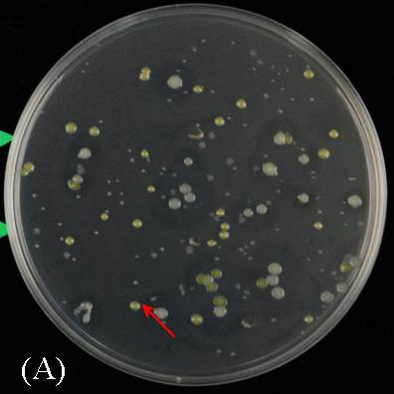
圖六、在CKTM培養基上黃色的Xanthomonas perforans菌落(A紅色箭頭所指)，外圍產生極淡的白色乳化沉澱圈(B)。

番茄細菌性葉斑病菌(Pseudomonas syringae pv. tomato)
本病原菌為我國重要檢疫病原。檢測方法係將種子於4℃下以緩衝液浸泡隔夜或至少14小時後蒐集萃取液，再以專一性引子對MM5F/MM5R (Massimo et al., 2005)進行PCR反應，此引子對可針對P. syringae pv. tomato之hrp Z _{PST}區間進行增幅，如經電泳分析可增幅得532bp的產物時，即判斷該樣品帶有P. syringae pv. tomato。
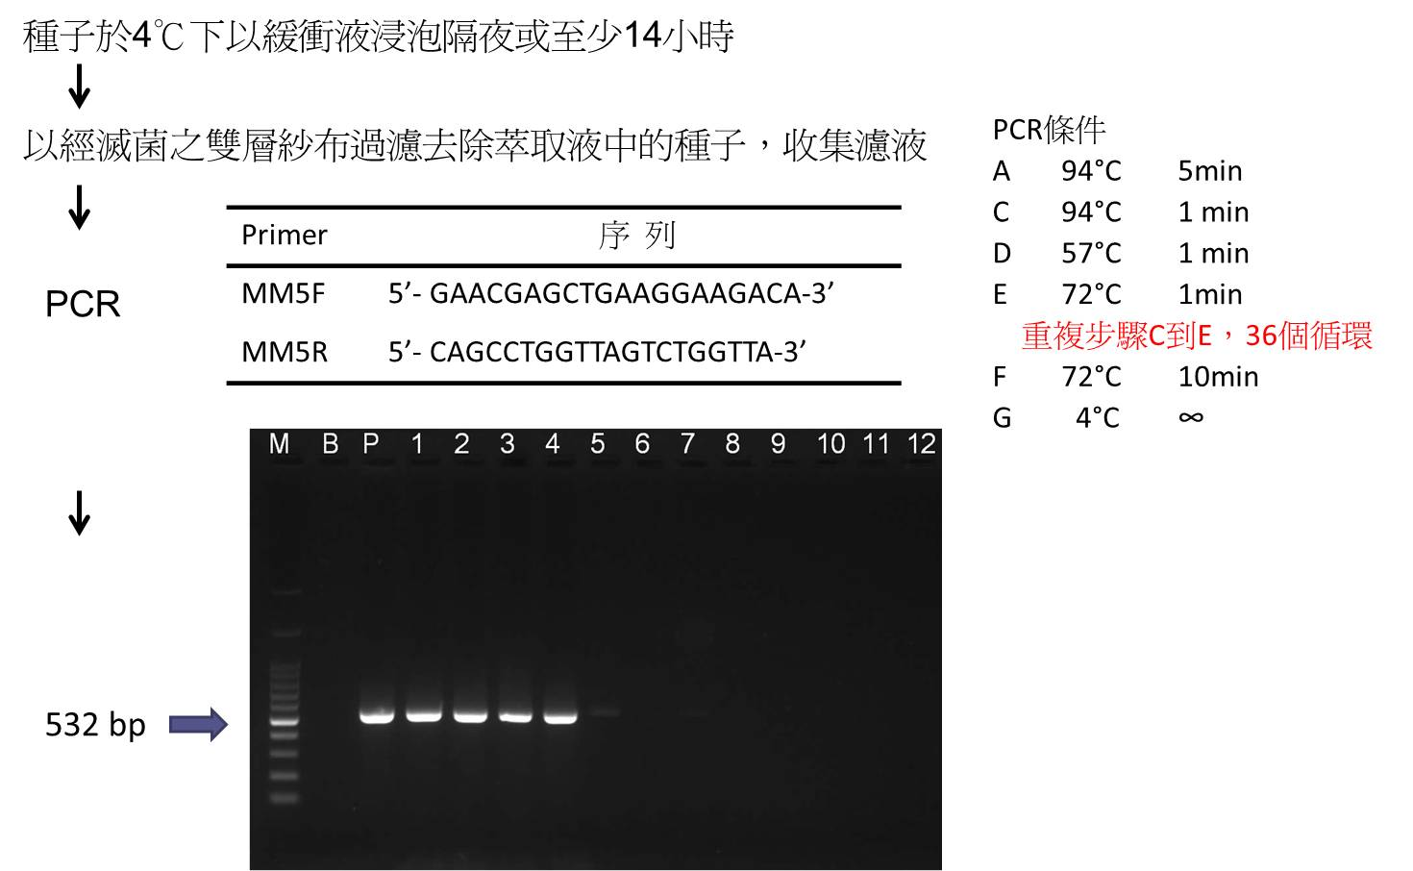
圖七、番茄細菌性葉斑病菌檢測流程示意圖

病毒病原(Viruses)
菸草嵌紋病毒(Tobacco mosaic virus, TMV)、豌豆種媒嵌紋病毒(Pea seed-borne mosaic virus, PSbMV)、南瓜嵌紋病毒(Squash mosaic virus, SqMV)、香瓜茄嵌紋病毒(Pepino mosaic virus, PMV)、香瓜壞疽斑點病毒(Melon necrotic spot virus, MNSV)、菸草微綠斑駁病毒(Tobacco mild green mottle virus, TMGMV)與豌豆早褐病毒(Pea early browning virus, PEBV)則同樣利用市面上購得之血清與所需之正負對照樣品，以直接酵素聯結抗體免疫吸附法(direct ELISA)進行檢測，再利用ELISA讀值分析儀分析。反應過程基質受酵素催化後，以405nm/492nm光波長之吸收值結果進行判讀。分析檢體之吸收值須與負反應對照組之吸收值相互比對，當檢體吸收值為負反應對照組吸收值的2倍以上，即判定該檢體含有目標病毒。
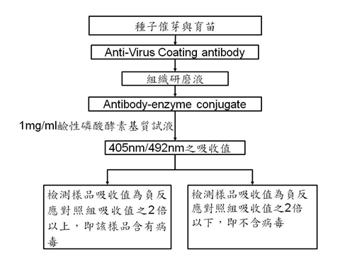
圖八、種傳病毒病原檢測流程示意圖

番茄與茄科種子類病毒(Pospiviroids of tomato and capsicum seeds)
診斷方法以兩階段式反轉錄聚合酶鏈鎖反應(2 steps Reverse transcription polymerase chain reaction, 2 steps RT-PCR)進行檢測，適用於馬鈴薯紡錘形塊莖類病毒(potato spindle tuber viroid, PSTVd)、番茄黃色矮化類病毒(Tomato chlorotic dwarf viroid, TCDVd)、辣椒小果類病毒(pepper chat fruit viroid, PCFVd)、番茄頂矮化類病毒(tomato apical stunt viroid, TASVd)、番茄類病毒((tomato planta macho viroid, TPMVd)、金魚藤潛伏類病毒(columnea latent viroid, CLVd)等六種類病毒。本方法利用4組引子對包括NADH-F、NADH-R、DHL-55F、DHL-56R、Pospi1F、Pospi1R、CLV4F、CLV4R等進行反轉錄聚合酶鏈鎖反應，其中NADH-F、NADH-R為植株常態表現之核醣核酸RNA偵測引子對，為比對RNA萃取效能之引子對，產物大小為188 bp；DHL-55F/DHL-56R可偵測PSTVd與TCDVd ，產物大小為354 bp；Pospi1F/Pospi1R可偵測PSTVd、TCDVd、TASVd、PCFVd與TPMVd，產物大小為196-228 bp；CLV4F/LV4R引子對則偵測CLVd，產物大小為373 bp。以電泳分析核酸增幅產物所呈現之條帶位置，進行結果判讀。
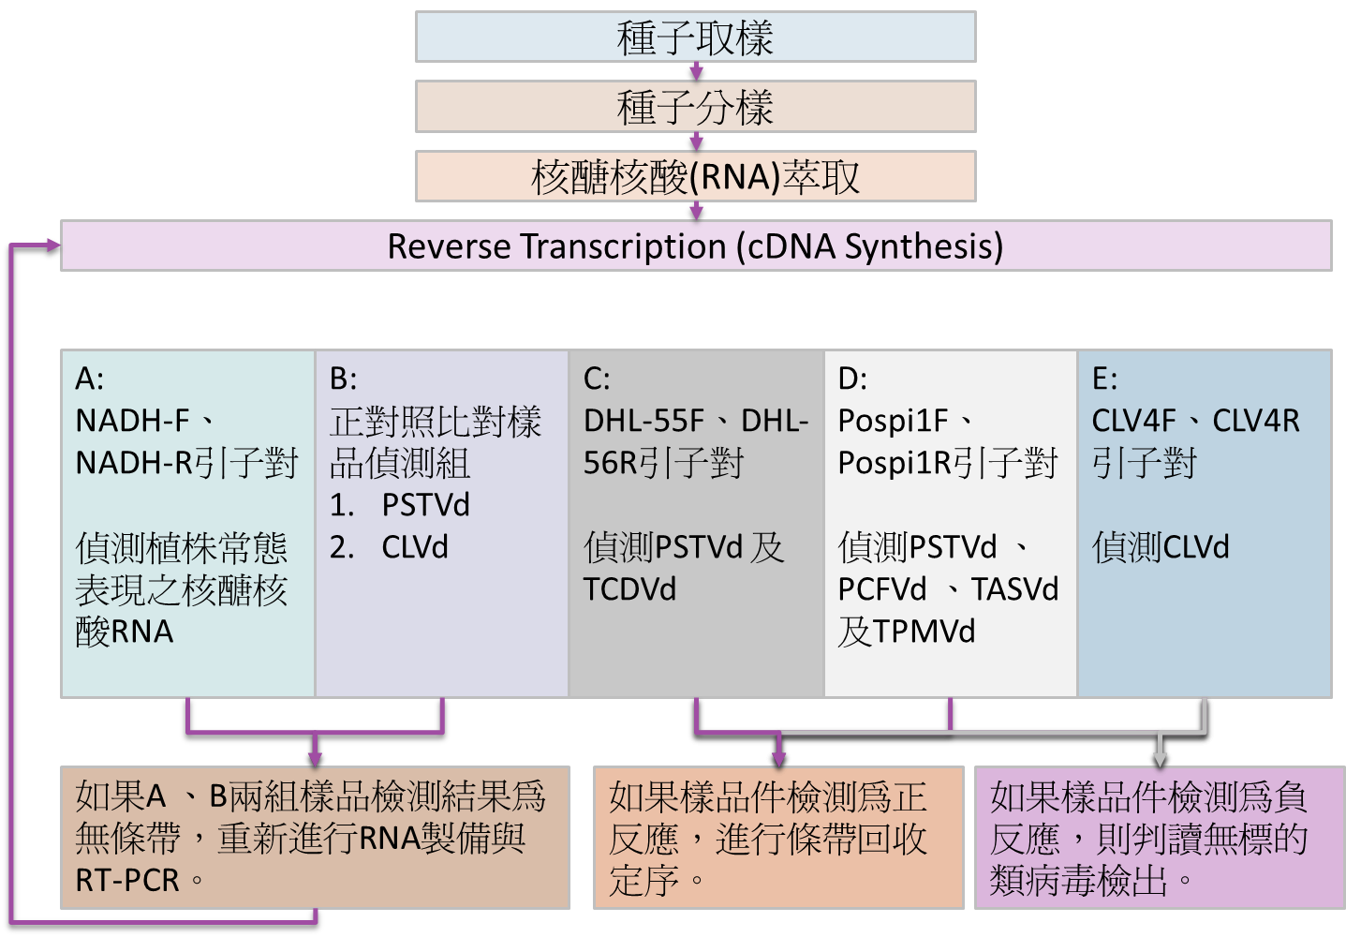
圖九、番茄與茄科種子類病毒檢測流程示意圖

結語
在種子健康檢查領域，國內大專院校與試驗研究機關進行種傳病原檢測之研究人員屈指可數，尤其可協助執行頻繁且大量檢測工作的人力也不足。近年來隨著檢疫檢測案件增加以及種子業者對檢測報告的需求提高，國內建立專責種傳病害檢測實驗室刻不容緩。在農委會與防檢局經費支持下，本場結合植物病理相關研究人員建立一種子健康檢查團隊，前述檢測流程部分項目已完成能力測試並由防檢局正式公告，未來期提供種子業者種傳病害檢測服務。

參考文獻
- 。1997。種帶植物病原細菌之偵測。植保會刊39:13-21。
- 曾淑菁。2011。甘藍黑腳病菌之生理特性及其病害防治。國立嘉義大學生物資源學系碩士論文。嘉義，台灣。72頁。
- 鄭安秀。2009。蔓枯病。頁89-92。植物保護圖鑑系列19－甜瓜保護。林正忠等著。行政院農業委員會動植物防疫檢疫局出版。台北，台灣。160頁。
- Bereswill, S., Bugert, P., Volksch, B., Ullrich, M., Bender, C. L., and Geider, K. 1994. Identification and Relatedness of Coronatine-Producing Pseudomonas syringae Pathovars by PCR Analysis and Sequence Determination of the Amplification Products. Applied and Environmental Microbiology 60:2924-2930.
- Berzal-Herranz, A., De La Cruz, A., Tenllado, F., Diaz-Ruiz, J. R., Lopez, L., Sanz, A. I., Vaquero, C., Serra, M. T., and Garcia-Luque, I. 1995. The Capsicum L3 gene-mediated resistance against the tobamoviruses is elicited by the coat protein. Virology 209:498-505.
- Desbiez, C. and Lecoq, H. 1997. Zucchini yellow mosaic virus. Plant Pathology 46:809-829. (Review)
- Elwakil, M. A. and Ghoneem, K. M. 2002. An improved method of seed health testing for detecting the lurked seed-borne fungi of Fenugreek. Pakistan J. Plant Pathol. 1(1):11-13.
- Gillet, J. M., Morrissey, S. M., and Ramsdell, D. C. 1986. Interpreting ELISA data and establishing the positive-negative threshold. Plant Dis. 70: 722-726.
- Haegi, A., Catalano, V., Luongo, L., Vitale, S., Scotton, M., Ficcadenti, N., and Belisario, A. 2013. A newly developed real-time PCR assay for detection and quantification of Fusarium oxysporum and its use in compatible and incompatible interactions with grafted melon genotypes. Phytopathology 103:802-810.
- ICTVdB Management. 2006. 00.071.0.01.007. Pepper mild mottle virus. In: ICTVdB - The Universal Virus Database, version Buchen-Osmond, C. (Ed), Columbia University, New York, USA. http://www.ncbi.nlm.nih.gov/ICTVdb/ICTVdB/00.071.0.01.007.htm.
- International Seed Federation. 2011. The International Seed Health Initiative for Vegetable Crops (ISHI-Veg): Method for the detection of Xanthomonas spp. in tomato seeds (version 4).
- International Seed Federation. 2011. The International Seed Health Initiative for Vegetable Crops (ISHI-Veg): Method for the detection of Xanthomonas spp. on pepper seeds (version 4).
- International Seed Testing association. 2008. International Rules for Seed Testing Chapter 7 Annexe 7-004: Detection of Phoma lingam on Brassica spp. Switzerland.
- International Seed Testing Association. 2013. International Rules for Seed Testing Chapter 7 Annexe 7-024: Detection of Pea Early-Browning Virus and Pea Seed-borne Mosaic Virus on Pisum sativum (pea). Switzerland.
- International Seed Testing Association. 2013. International Rules for Seed Testing Chapter 7 Annexe 7-026: Detection of Squash Mosaic Virus, Cucumber Green Mottle Mosaic Virus and Melon Necrotic Spot Virus in cucurbits. Switzerland.
- International Seed Testing Association. 2013. International Rules for Seed Testing Chapter 7 Annexe 7-028: Tobamoviruses on Lycopersicon esculentum. Switzerland.
- Luongo, L., Vitale, S., Haegi A., and Belisario A. 2012. Development of SCAR markers and PCR assay for Fusarium oxysporum f. sp. melonis race 2-specific detection. Journal of Plant Pathology 94:193-199.
- Massimo Zaccardelli, Annalisa Spasiano, Carlo Bazzi and Massimo Merighi. 2005. Identification and in planta detection of Pseudomonas syringae pv. tomato using PCR amplification of hrp Z_{Pst}. European J. Plant Pathol. 111: 85-90.
- Mathur, S. B. and Kongsdal, O. 2003. Chapter 5. Blotter method. p89-317. Common laboratory seed health testing methods for detecting fungi. 1st ed. 425p. International Seed Testing Association published. Bassersdorf, CH-Switzerland.
- National Seed Health System. 2013. Vegetable Crops. http://www.seedhealth.org/files/pdf/Vegetable_Crops.pdf
- Simmons, H. E., Holmes, E. C., Gildow, F. E., Bothe-Goralczyk, M. A., and Stephenson, A. G. 2011. Experimental verification of seed transmission of Zucchini yellow mosaic virus. Plant Dis. 95:751-754.
- Shila, S. J., Islam, M. R., Ahmed, N. N., Dastogeer, K. M. G., and Meah, M. B. 2013. Detection of Pseudomonas syringae pv. lachrymans associated with the seeds of cucurbits. Universal Journal of Agricultural Research 1:1-8.
- Szopinska, D., Tylkowska, K., Deng, Ch. J. and Gao, Y. 2012. Comparison of modified blotter and agar incubation methods for detecting fungi in Zinnia elegans seeds. Seed Sci. and Technol. 40:32-42.
- Takikawa, Y. and Takahashi, F. 2014. Bacterial leaf spot and blight of crucifer plants (Brassicaceae) caused by Pseudomonas syringae pv. maculicola and P. cannabina pv. alisalensis. J Gen Plant Pathol 80:466–474.
- Ye, L. F., Zhou, G. L., Yin, L. P., Bai, Z. H., Li, X. J., Yang, S. J., Yi, J. P. 2015. Detection of Pseudomonas syringae pv. maculicola from imported rape seeds. Acta Phytopathologic Sinica 45:410-417.

Summary
Establishment of Detection Techniques on Seed-borne Pathogens of Important Exportable Seeds
Shih-Min Su^{1#}, Yen-Hsin Chiu¹, Wen-Chuan Chung²,
Hui-Ju Wang³, Chun-Yen Liu³, Liang-Fen Jian³, Ping-Shan Wei⁴
¹ Assistant researcher of Taiwan Seed Improvement and Propagation Station
² Researcher of Taiwan Seed Improvement and Propagation Station
³ Research assistant of Taiwan Seed Improvement and Propagation Station
⁴ Former research assistant of Taiwan Seed Improvement and Propagation Station
#Corresponding author: No.6, Xingzhong St., Xinshe Dist., Taichung City 42642, Taiwan (R.O.C.); E-mail address: armin@tss.gov.tw
Key words: seed-borne pathogens, detection, exportable seeds
Since 2013, Taiwan Seed Improvement and Propagation Station was appointed by Bureau of Animal and Plant Health Inspection and Quarantine to develop standard operation procedures (SOPs) for detection of seed-borne pathogens on Taiwan exportable vegetable seeds. Fourteen SOPs have been established to test twenty-two pathogens, which include Phoma lingam, Didymella bryoniae, Colletotrichum lindemuthianum, Ascochyta pisi, Xanthomonas vesicatoria, X. euvesicatoria, X. perforans, X. gardneri, Pseudomonas syringae pv. tomato, Tobacco mosaic virus, Pea seed-borne mosaic Virus, Squash mosaic virus, Pepino mosaic virus, Melon necrotic spot virus, Tobacco mild green mottle virus, Pea early browning virus and six Pospiviroids.

